**Example No.01**

<html>

<body>

<h2>JavaScript Arrays</h2>

<p>The best way to loop through an array is using a standard for

loop:</p>

<p id="demo"></p>

<script>

var fruits, text, fLen, i;

fruits = ["Banana", "Orange", "Apple", "Mango"];

fLen = fruits.length;

text = "<ul>";

for (i = 0; i < fLen; i++) {

text += "<li>" + fruits[i] + "</li>";

}

text += "</ul>";

document. getElementById("demo"). innerHTML = text;

</script>

</body>

</html>

**Example No.02**

<html>

<body>

<p>This "home made" isArray() function returns true when used on an array:</p>

<p id="demo"></p>

<script>

var fruits = ["Banana", "Orange", "Apple", "Mango"];

document.getElementById("demo").innerHTML = isArray(fruits);

function isArray(myArray) {

return myArray.constructor.toString().indexOf("Array") > -1;

}

</script>

</body>

</html>

**Example No.03**

<html>

<body>

<h2>JavaScript Array Sort</h2>

<p>Click the buttons to sort car objects on age.</p>

<button onclick="myFunction()">Sort</button>

<p id="demo"></p>

<script>

var cars = [

{type:"Volvo", year:2016},

{type:"Saab", year:2001},

{type:"BMW", year:2010}]

displayCars();

function myFunction() {

cars.sort(function(a, b){return a.year - b.year});

displayCars();

}

function displayCars() {

document.getElementById("demo").innerHTML =

cars[0].type + " " + cars[0].year + "<br>" +

cars[1].type + " " + cars[1].year + "<br>" +

cars[2].type + " " + cars[2].year;

}

</script>

</body>

</html>

**Example No.04**

<!DOCTYPE html>

<html>

<body>

<h2>JavaScript Array Sort</h2>

<p>Click the buttons to sort car objects on type.</p>

<button onclick="myFunction()">Sort</button>

<p id="demo"></p>

<script>

var cars = [

{type:"Volvo", year:2016},

{type:"Saab", year:2001},

{type:"BMW", year:2010}]

displayCars();

function myFunction() {

cars.sort(function(a, b){

var x = a.type.toLowerCase();

var y = b.type.toLowerCase();

if (x < y) {return -1;} // lexicographical order

if (x > y) {return 1;}

return 0;

});

displayCars();

}

function displayCars() {

document.getElementById("demo").innerHTML =

cars[0].type + " " + cars[0].year + "<br>" +

cars[1].type + " " + cars[1].year + "<br>" +

cars[2].type + " " + cars[2].year;

}

</script>

</body>

</html>

**Example No.05**

<!DOCTYPE html>

<html lang="en">

<body>

<button class="btn" onclick="showProperties()">Click me</button>

<br><br>

<div id="demo">

<h3>Heading</h3>

<p>Lorem ipsum dolor sit amet consectetur adipisicing elit. Nam voluptatem voluptates dolores sed ipsum distinctio nesciunt nostrum eos repudiandae debitis dolorum inventore, libero, facere, non vero ad sequi ea ut.</p>

</div>

<p id="showCase"></p>

<script>

"use strict";

function showProperties(){

let demoDiv = document.querySelector("#demo");

let props = getComputedStyle(demoDiv);

let txt = "";

for(var i = 0 ; i < props.length; i++){

var propertyVal = props.item(i);

txt += propertyVal + " : " +

props.getPropertyValue(propertyVal) + "<br>";

}

document.getElementById("showCase").innerHTML = txt;

}

</script>

</body>

</html>

**Example No.06**

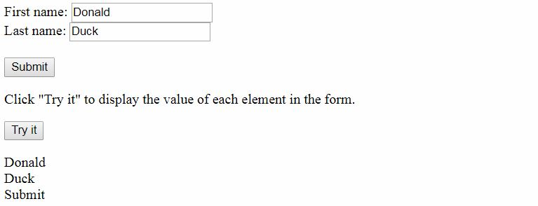

<!DOCTYPE html>

<html>

<body>

<form id="frm1" action="https://www.w3schools.com/action_page.php">

First name: <input type="text" name="fname" value="Donald"><br>

Last name: <input type="text" name="lname" value="Duck"><br><br>

<input type="submit" value="Submit">

</form>

<p>Click "Try it" to display the value of each element in the form.</p>

<button onclick="myFunction()">Try it</button>

<p id="demo"></p>

<script>

function myFunction() {

var x = document.forms["frm1"];

var text = "";

var i;

for (i = 0; i < x.length ;i++) {

text += x.elements[i].value + "<br>";

// elements[i] = built-in function

}

document.getElementById("demo").innerHTML = text;

}

</script>

</body>

</html>

**Example No.07**

<!DOCTYPE html>

<html lang="en">

<head>

<style>

#container{

position: relative;

width: 550px;

height: 550px;

background-color: #f3f3f3;

border: 1px solid #ccc;

border-radius: 4px;

}

#mini-container{

position: absolute;

width: 100px;

height: 100px;

background-color: #ddd;

border-radius: 4px 0 4px 0;

}

</style>

</head>

<body>

<div id="container">

<div id="mini-container">

</div>

</div>

<script>

let smallBox = document.querySelector("#mini-container");

let container = document.querySelector("#container");

let x = 0; // 450px

let boxInterval = setInterval(run, 5);

function run(){

if( x == 450){

clearInterval(boxInterval);

} else {

x++;

smallBox.style.top = x + "px";

smallBox.style.left = x + "px";

}

}

</script>

</body>

</html>

**Example No.08**

<!DOCTYPE html>

<html lang="en">

<body>

<div id="demo"></div>

<script>

let i, res, browsers = ['Chrome', 'Firefox', 'Trident', 'Safari', 'MSIE'];

for (i = 0; i < browsers.length; i++) {

if (navigator.userAgent.indexOf(browsers[i]) > -1) {

if (browsers[i] == "Trident") {

res = "Internet Explorer";

break;

}

res = browsers[i];

break;

}

}

document.getElementById("demo").innerHTML = "You are using "

+ res + " browser!";

</script>

</body>

</html>